**2nd Lt David Crow**

**ENG/20M**

**CSCE 560 Homework / Wireshark Lab 1**

**Chapter 1 – Computer Networks and the Internet**

**Fall 18**

**Assigned: Monday, 1 Oct**

**Due: Monday, 15 Oct, 1400**

**Problem 1.**  Chapter 1, P6

This elementary problem begins to explore propagation delay and transmission delay, two central concepts in data networking. Consider two hosts, A and B, connected by a single link of rate *R* bps. Suppose that the two hosts are separated by *m* meters, and suppose the propagation speed along the link is *s* meters/sec. Host A is to send a packet of size *L* bits to Host B.

* 1. Express the propagation delay, *dprop*, in terms of *m* and *s*.
 $$d_{prop}=\frac{m}{s}$$

 2. Determine the transmission time of the packet, *dtrans*, in terms of *L* and *R*.
 $$d_{trans}=\frac{L}{R}$$

 3. Ignoring processing and queuing delays, obtain an expression for the end-to-end delay.
 $$d_{end_to_end}=N_{packets}*\left(d_{proc}+d_{trans}+d_{prop}\right)=1*\left(0+\frac{L}{R}+\frac{m}{s}\right)=\frac{L}{R}+\frac{m}{s}=\frac{Ls+Rm}{Rs}$$

 4. Suppose Host A begins to transmit the packet at time *t* = 0. At time *t* = *dtrans*, where is the last bit of the packet?

At time ${t=d}_{trans}$, the last bit of the packet is immediately outside the router. That is, the bit has been pushed out of the router and onto the link, but it hasn’t had enough time to *go* anywhere.

* 1. Suppose *dprop* is greater than *dtrans*. At time *t* = *dtrans*, where is the first bit of the packet?

If $d_{prop}>d_{trans}$, we know that it takes longer for a bit to propagate to the next router than for the original router to push the entire packet onto the link. Because of this, we know that, at time $t=d_{trans}$, the first bit of the packet is somewhere between the original router and the next router. In fact, all of the packet’s bits are on the link between routers.

* 1. Suppose *dprop* is less than *dtrans*. At time *t* = *dtrans*, where is the first bit of the packet?

In this case, a bit can travel from one router to the next before an entire packet can be pushed onto the link. Thus, at time $t=d_{trans}$, the first bit of the packet is waiting (and has been waiting – at least a little while) at the next router for all of the packet’s bits to arrive.

* 1. Suppose *s* = 2.5 x 108, *L* = 120 bits, and *R* = 56 kbps. Find the distance *m* so that *dprop* equals *dtrans*.

**Problems 2.** Chapter 1, P7

In this problem, we consider sending real-time voice from Host A to Host B over a packet-switched network (VoIP). Host A converts analog voice to a digital 64 kbps bit stream on the fly. Host A then groups the bits into 56-byte packets. There is one link between Host A and B; its transmission rate is 2 Mbps and its propagation delay is 10 msec. As soon as Host A gathers a packet, it sends it to Host B. As soon as Host B receives an entire packet, it converts the packet's bits to an analog signal. [Assume the conversion of the digital signal back to analog takes 0 seconds.] How much time elapses from the time a bit is created (from the original analog signal at Host A) until the bit is decoded (as part of the analog signal at Host B)?

It takes $\frac{56 * 8 bits}{64*{10}^{3} \frac{bits}{second} }=0.007 seconds=7 milliseconds$ to generate a packet.

The link requires $\frac{56 * 8 bits}{2*{10}^{6} \frac{bits}{second}}=0.000224 seconds=0.224 milliseconds$ to transmit a packet.

The propagation delay, $10 milliseconds$, is given to us.

Thus, $7 milliseconds+0.224 milliseconds+10 milliseconds=17.224 milliseconds$ is the total time elapsed from the time a bit is created until it’s decoded at Host B.

**Problem 3.** Chapter 1, P25

Suppose two hosts, A and B, are separated by 20,000 kilometers and are connected by direct link of *R* = 2 Mbps. Suppose the propagation speed over the link is 2.5 x 108 meters/sec. Assume the protocol does not require acknowledgements.

* 1. Calculate the bandwidth-delay product, *R* x *dprop*.
  2. Consider sending a file of 800,000 bits from Host A to Host B. Suppose the file is sent continuously as one big message. What is the maximum number of bits that will be in the link at any given time?

* 1. Provide an interpretation of the bandwidth-delay product [for this scenario as well as if acknowledgements were required].

As shown in *part a* and in *part b*, the bandwidth-delay product is a measure of the maximum amount of information (or data) on the link at any given point in time.

* 1. What is the width (in meters) of a bit in the link? Is it longer than a football field?

If we assume the bits fill the link completely, $\frac{length}{number_of_bits}=\frac{20000*{10}^{3} meters}{160000 bits}=125 meters$.

A football field is $100 yards=91.44 meters<125 meters$, so a bit is longer than a football field.

* 1. Derive a general expression for the width of a bit in terms of the propagation speed *s*, the transmission rate *R*, and the length of the link *m*.

As shown above, the length of a bit is the length of the link divided by the bandwidth-delay product.

In other words, $length_{bit}=\frac{length_{link}}{R*d_{prop}}=\frac{length_{link}}{R}*\frac{v_{prop}}{length_{link}}=\frac{m}{R}*\frac{s}{m}=\frac{s}{R}$.

**Problem 4.**  Chapter 1, P26

Referring to problem 25, suppose we can modify R. For what value of R is the width of a bit as long as the length of the link?

$length_{bit}=\frac{s}{R}=m$ when $R=\frac{s}{m}$, so $R=\frac{2.5*{10}^{8} \frac{meters}{second}}{20000*{10}^{3} meters}=12.5\frac{bits}{second}$.

**Problem 5.**  Chapter 1, P27

Consider problem 25 but now with a link of R = 1 Gbps.

1. Calculate the bandwidth-delay product, R x dprop.
2. Consider sending a file of 800,000 bits from Host A to Host B. Suppose the file is sent continuously as one big message. What is the maximum number of bits that will be in the link at any given time?

Because the link’s larger bandwidth-delay product is larger than the size of the file, we can send the entire file at once. That is, all 800,000 bits can be in the link at one time.

1. What is the width (in meters) of a bit in the link?

$$length_{bit}=\frac{s}{R}=\frac{2.5*{10}^{8} \frac{meters}{second}}{1*{10}^{9} \frac{bits}{second}}=0.25 meters$$

**Problem 6.**  Chapter 1, P28

Refer again to problem 25.

1. How long does it take before the entire file is received at the destination assuming it is sent continuously?

Because the bits are sent continuously, we only need to sum $d_{prop}=0.08 seconds$ and

$d_{trans}=\frac{L}{R}=\frac{800000 bits}{2*{10}^{6} \frac{bits}{second}}=0.4 seconds$. Thus, it takes $0.40+0.08 seconds=480 milliseconds$ to transmit the file.

1. Suppose now the file is broken up into 20 packets with each packet containing 40,000 bits. Suppose that each packet is acknowledged by the receiver and the transmission time of an acknowledgment packet is negligible. Finally, assume that the sender cannot send a packet until the preceding one is acknowledged. How long does it take to send the file?

Because $40000<160000$, we won’t experience any queuing within a given packet, so we can effectively send each packet all at once. Because we can’t send a new packet until the previous one is acknowledged, this will take $n*\left({2*d}_{prop}+d_{trans}\right) seconds$. We multiply $d_{prop}$ by $2$ because we have to wait for the acknowledgement packet.

Thus, this takes $20*\left(2*0.08 seconds+\frac{L}{R}\right)=20\left(0.16 seconds+\frac{40000 bits}{2*{10}^{6 }\frac{bits}{second} }\right)=3.6 seconds$.

**Problem 7.**  Chapter 1, P29

Suppose there is a 10 Mbps microwave link between a geostationary satellite [36 x 106 meters above Earth] and its base station on Earth. Every minute the satellite takes a digital photo and sends it to the base station. Assume a propagation speed of 2.4 x 108 meters/sec. Also assume acknowledgements are not required.

1. What is the propagation delay of the link?
$$d_{prop}=\frac{distance}{v_{prop}}=\frac{36*{10}^{6} meters}{2.4*{10}^{8} \frac{meters}{second}}=0.15 seconds$$

2. What is the bandwidth-delay product, R x dprop?
3. Let x denote the size of the photo. What is the minimum value of x for the microwave link to be continuously transmitting?

The satellite transmits 10 megabits every second, and it takes a photo every 60 seconds. Thus, pictures must have a size of $10*{10}^{6}\frac{bits}{second}*60 seconds=6*{10}^{8} bits=0.6 gigabits$ to ensure the satellite transmits continuously.

**Problem 8.** Chapter 1, P31

In modern packet-switched networks, including the Internet, the source host segments long, application-layer messages (for example, an image or a music file) into smaller packets and sends the packets into the network. The receiver then reassembles the packets back into the original message. We refer to this process as message segmentation. Figure 1.27 illustrates the end-to-end transport of a message with and without message segmentation. Consider a message that is 8 x 106 bits long that is to be sent from source to destination in Figure 1.27. Suppose each link in the figure is 2 Mbps. Ignore propagation, queuing, and processing delays.

1. Consider sending the message from source to destination *without* message segmentation. How long does it take to move the message from the source host to the first packet switch? Keeping in mind that each switch uses store-and-forward packet switching, what is the total time to move the message from source host to destination host?

It takes $\frac{8*{10}^{6} bits}{2*{10}^{6} \frac{bits}{second}}=4 seconds$ to send the packet to the first link.

Because there are three links, it takes $4 seconds*3=12 seconds$ to send the entire message.

1. Now suppose that the message is segmented into 800 packets, with each packet being 10,000 bits long. How long does it take to move the first packet from source host to the first switch? When the first packet is being sent from the first switch to the second switch, the second packet is being sent from the source host to the first switch. At what time will the second packet be fully received at the first switch?

It takes $\frac{10000 bits}{2*{10}^{6} \frac{bits}{seconds}}=0.005 seconds=5 milliseconds$ to send a packet to the first switch.

The second packet has to wait for the first packet to cross to and then leave the first switch, and it then takes the same amount of time to reach the first switch itself. Thus, the second packet will be received at the first switch after $2*5 milliseconds=10 milliseconds$.

1. How long does it take to move the file from source host to destination host when message segmentation is used? Compare this result with your answer in part (a) and comment.

It takes the first packet $3*5 milliseconds=15 milliseconds$ to reach the destination. After the first packet arrives, a new packet will arrive at the destination every 5 ms, so it takes $15 milliseconds+\left(800-1\right)*5 milliseconds=4010 milliseconds=4.01 seconds$.

It’s obvious that 4.01 seconds is much better than 12 seconds. In fact, packet-switching allows this network to transmit a file almost 300% faster than a non-packet-switched network.

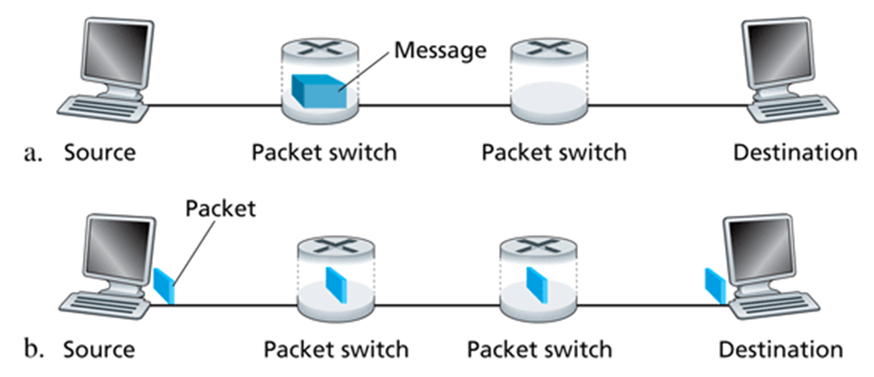

**Problem 9.** History of Networking Video

Watch the video Modern Marvels Wiring America.mp4 from 32:00 minutes to the end (44:18). Indicate on your homework solution that you actually watched the video.

I watched the video.

**Wireshark Lab**

Complete the lab in 01 - Wireshark_Intro.pdf.

Okay.